Snapshots of code to show accomplishment:

Client side:

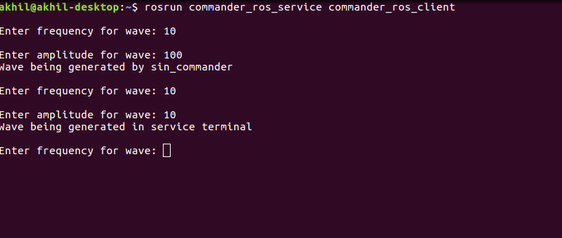

Service side:

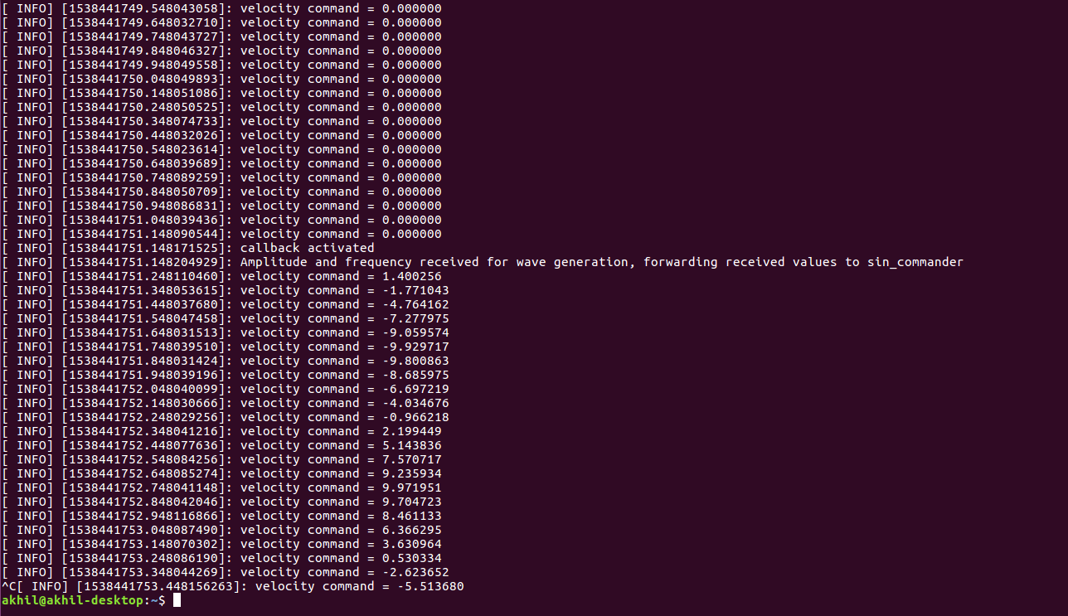
As soon as inputs are received the service updates and sends client a message saying the given inputs have been received and the result is being published.

